15.38: The ends of the stick are free, so they must be displacement antinodes.
1st harmonic:
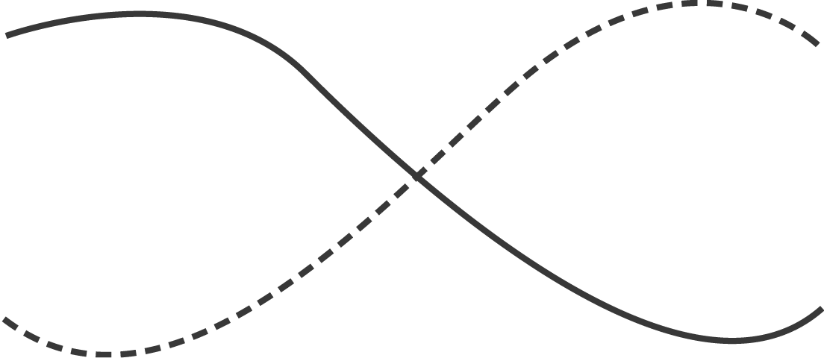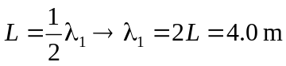
2nd harmonic:
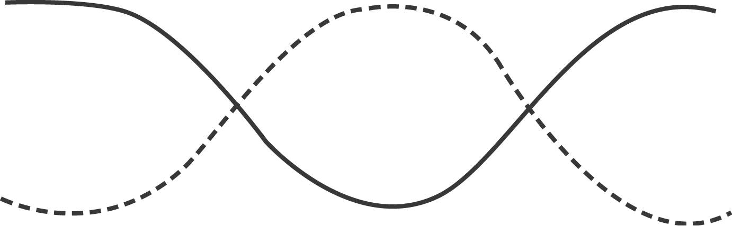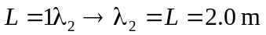
3rd harmonic:
